WTMS-1000 is a real time on-line data gathering, storage and transmission system. Data logger is also used as Station management and maintenance management program. So it is working as total environmental information system in each measuring station

TMS description
Water TMS(Tele-metering system) is a total environmental information system and station management system of pollution monitoring in Water. It gather data from each analyzers and additional instruments i.e. filter, pump etc. All measuring data from on-line analyzers/equipments in each station are gathered, stored and managed. It will basic information for environmental pollution tracking. TMS will be used to monitor pollution accident and also accumulate long term water quality information.
In addition, through real time alarm function, If the measuring data exceed the limit, TMS will give alarm
immediately to operator to act accordingly.

Configuration

Local Monitoring Station
Water TMS Center

Government

Local TMS

Check Module

Windows 7

Remote control Transmission module

Communi- cation line
DBMS

Control center DB Server

CLIENT

Control

Research

Local Gov.

Internet/Wireless Network

Data Logger
Data Logger

TOC
TN TP Flow
pH SS
SAMPLER
TOC
TN TP Flow
pH SS
SAMPLER

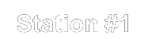
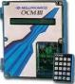
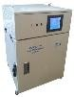
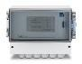
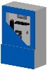
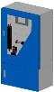
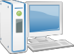
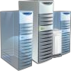
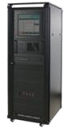
COPYRIGHT 2015 BY BL PROCESS CO., LTD. ALL RIGHTS RESERVED. VER2.1
SENSOR & ANALYZER SENSOR & ANALYZER

1312 Ace Pyeongchon tower, 361 Simin-daero, Dongan-gu, Anyang-si, Gyeonggi-do, 431-804 Korea TEL: +82-(0)31-345-8200, FAX:+82-(0)31-345-8202, http://www.blprocess.co.kr, Email:info@blprocess.co.kr

Major function
Data gathering • It gather measuring data and status information from the measuring instrument and additional instrument. This enables to
decide whether data are useful or not.

Data Transmission • Data logger send measuring data and status information to Control Center.
- Communication server analyze, save and manage data to DB server through communication TCP/IP network which is connected to terminal server.
- Data dump to server

Set up & Control • Set up station sensor, analyzer and related equipment.
- Data logger works based on the command from control center to
each analyzer and instrument and it give feedback to control center regarding the result. Through data logger, Control center can control each available instrument at station.
- Different level of Data logger access by name and password
  - Level1(operator): only view data, status, time etc
  - Level2(Administrator) : allowing all feature on D/L
- Set thresholds for each parameters and each analog input
- Time synchronization feature

Status Information • Instrument status: Normal running, Calibrating, Servicing, Error, System stop, Communication error
- Station information: Electricity, Door, Sample flow, Pump status, Fire alarm, Station temp./humidity

Display • Display: Real time, 5min, 1hour data(changeable time period)
- Easy to see data with table or graphical mode
- Display single data or multi data.

Data storage • Set up data storage for real time data, 5 min data, 1hour data
- USB backup and restore
- More than 1year data storage capability

Other feature • Programmable for Digital input/output, Analog Input
- Alarm set-up for each parameters
- SMS module(option)

System configuration
Configuration Specification Application Processor CPU • Intel Core I5 or higher
Memory RAM/HDD • 4GB or higher / 500GB or higher
Peripheral Display/Keyboard • LCD/Keyboard and Mouse
OS Microsoft O/S • Support Windows 7 or higher

Interface

Comm. Port

I/O module

Support Windows Server 2008 or higher
- 8 x RS-232 (Modbus) ports
- 1 x RS485 port
- USB
- 16 x Digital Input channels
- 08 x Digital Output channels, dry contact, 220VAC-0.5A
- 16 x Analog Input (0/4- 20 mA) channels
- Surface water quality
: River/Reservoir/Sea water
- Water intake inspection
- Effluent water inspection
- Waste TMS monitoring

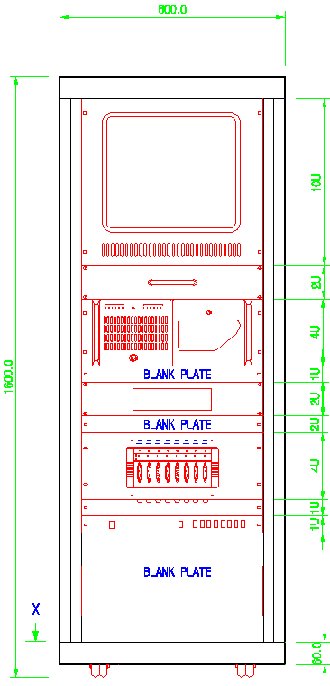
Network LAN • 10/100MBps
COPYRIGHT 2015 BY BL PROCESS CO., LTD. ALL RIGHTS RESERVED. VER2.1
Chassis Industrial • 19" Rack Type
1312 Ace Pyeongchon tower, 361 Simin-daero, Dongan-gu, Anyang-si, Gyeonggi-do, 431-804 Korea TEL: +82-(0)31-345-8200, FAX:+82-(0)31-345-8202, http://www.blprocess.co.kr, Email:info@blprocess.co.kr

